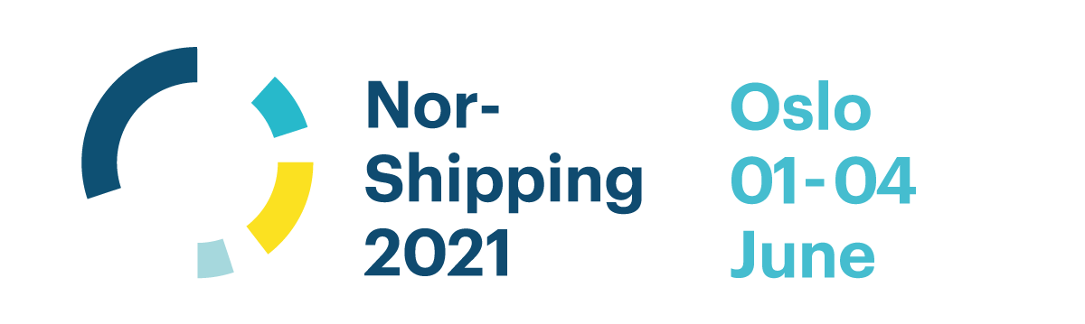
GERMAN PAVILION
at NOR-SHIPPING 2021

Application Form
Company
Address
Contact Person
Phone
Mail
Internet

We hereby order stand number : 1th priority

2nd priority
For stand numbers and updated availability please see general stand overview on the project website. www.handelskammer.no/nor-shipping .

PLEASE NOTE THE WE WILL ALLOCATE STANDS ON A FIRST COME, FIRST SERVE BASIS!
Other remarks:

☐ We accept the GERMAN PAVILION terms and conditions.
☐ We agree to receive relevant information concerning the GERMAN PAVILION at Nor-Shipping 2021
on the e-mail address given above.

Place, date Name and signature, company stamp
Please return the application form to:
E-mail: tk@handelskammer.no

German Pavilion
Organiser: Deutsch-Norwegische Handelskammer Services AS (DNHKS) in cooperation with Hamburg Messe and Congress GmbH
Drammensveien 111 B
0273 Oslo / Norwegen
Tereza Kjos
+47 22 12 82 46
tk@handelskammer.no
Andreas Totzauer
+47 22 12 82 12
at@handelskammer.no
Project manager:
Phone:
E-mail:

Hamburg Messe and Congress gmbH
Messeplatz 1 · 20357 Hamburg · Germany

Merle Schöning
+49 40 35 69 22 83
merle.schoening@hamburg-messe.de

The GERMAN PAVILION at Nor-Shipping 2021 is the place where you will meet existing and potential new clients gathering together to discuss the industry needs. For the coming edition we can offer you again an improved design and concept based on system with largely reusable parts. While maintaining a high-livel quality, this will accomodate our common responsibility in terms of sustainability. Our pavilion design guidelines will provide a strong presentation of the German maritime industry.

Services Included
- Catalogue entry in publication of trade fair organiser
- German branded stand design to draw visitors to the Pavilion
- Dedicated project manager and team to assist prior to and onsite at the show
- Pavilion lounge with light lunch and refreshments throughout the day
- General information desk manned at all time during the exhibition period
- Prime location in Hall C at the show
- Promotion of the pavilion through various activities prior to the exhibition
- 1 year of membership at the German Norwegian Chamber of Commerce (01.01.2021 – 31.12.2021)
- Fixed cost inclusive of stand area, high quality stand design and construction
- Uniform floor covering (dark carpet)
- White textile walls (print as surcharge)
- General lighting, 1 electrical outlet
- 1 counter, 1 bar table, 2 bar chairs, 1 waste basket
- Free registration and listing of sub-exhibitors

As always, we will strive to make your stay with us as comfortable and rewarding as possible, providing opportunities to generate new businesses and strengthen your existing commercial and social ties.

Terms & Conditions
1. Registration
The registration will be confirmed in writing with a binding effect. Due to the changed stand concept will stands be sold on a first come, first serve basis. In case that several exhibitors are interested in one particular stand, the allocation will be determined by time and date of the incoming application.

2. Terms of Payment
When registrating, 20% of the participation fee is to be paid as deposit. The rest of the participation fee (80%) will be invoiced in January 2021. After completion of the event, exhibitors will receive a final invoice of individually incurred costs not covered by the standard package. All invoices are due in 21 days of the invoice date, unless agreed otherwise.
3. Cancellation by exhibitor
The exhibitor can cancel until 15.12.2020 and receive back the deposit or the participation fee paid until then.
In case of cancellation later than 15.12.2020, 100% of the participation fee is to be paid.
4. Stand Allocation
Please specify preferred stand number. Stand size and layout is not negotiable. In case of lack of space or of registrations after the deadline, DNHKS and HMC reserve the rights to find another suitable location within the pavilion. We reserve also the right to make slight adjustments in size and dimensions, if necessary. The exhibitors will always be informed about potential changes.
5. Obligations of Deutsch-Norwegische Handelskammer Services AS
DNHKS is committed to arrange the event as described in the registration form, provided a sufficient number of participants. In the case of an insufficient number of participants or significant changes in external preconditions, DNHKS can dissolve the event. In this case, information will be given to participants in good time. Paid registration fees will be refunded. In the event of a cancellation due to insufficient number of participants based on the judgement of Norway Trade Fairs any registration fees will be refunded, exempt other costs incurred until the day of cancellation, including project management. In case of Norway Trade Fairs has asked for feedback prior to cancellation DNHKS will on behalf of the participants pass them through.
6. Force Majeure
DNHKS is not accountable if the implementation of the project fails due to circumstances that are beyond the control of DNHKS, such as: strikes, natural disasters, lockout, changes in legislation, or similar. If, due to the above mentioned conditions, the project can not be performed, the registered participants are liable for the costs incurred, including project management.
7. Disagreements
If disagreements arise connected to this project, the legal department of DNHKS will try to resolve the dispute. Should this not lead to success, the parties will authorize the Oslo City Court for a judicial resolution of the dispute

